PRESENTING CLINICAL SIGNS
History: Intermittent recurrent hematochezia past 1 month, weight loss, eating and drinking less. Previous history of pancreatitis and pituitary-dependent Cushing’s disease.
Physical Examination: N/A.
Urinalysis: N/A.
CBC: N/A.
Serum Biochemistry: N/A.
Radiographic Findings: N/A.

ULTRASONOGRAPHIC EXAMINATION OF THE ABDOMEN
Urinary System
Full urinary bladder with a normal thickness and appearance of the wall. Normal anechoic urine with no sediment or uroliths evident.
Normal trigone area, proximal urethra (0.4 cm), and iliac blood vessels.
Normal iliac lymph nodes (1 cm). Ureters not visualized.
Normal renal size (left 3.8 cm, right 4.1 cm) with increased echogenic appearance, some loss of cortico-medullary differentiation, and normal pelvis and capsule.
Reproductive System
N/A.
Adrenal Glands
Left - normal shape and position, hypoechogenic appearance, and enlarged (0.77/0.61 cm).
Right adrenal – enlarged with an irregular shape and a mottled echogenic appearance (1.6 x 2.3 cm) with no obvious invasion of the surrounding vasculature.
Spleen
Normal size and echogenic appearance. Smooth homogenous parenchyma, regular curvilinear capsule, and normal vasculature. Small focal hypoechogenic parenchymal nodule (0.6 cm) in the body of the spleen. No evidence of inflammatory, neoplastic, infarction, or infiltrative changes noted.
Liver
Normal size with a mottled echogenic appearance, loss of portal markings, and regular curvilinear capsule. Poorly defined hyperechogenic parenchymal mass (1.8 x 3.3 cm) in the left lobe. No nodules evident. Full gall bladder containing moderate amount of adhered and non-adhered hyperechogenic sediment. Normal thickness and echogenic appearance of the gall bladder wall. Normal bile duct (0.2 cm).
Gastrointestinal
Normal appearance of the stomach, duodenum, and ileo-cecal junction, with no loss of layering, normal wall thickness and peristaltic activity, and no distension of the lumen. Segmental thickening of the small intestine (0.52 cm) and colon (0.3 cm) with no loss of layering or distension of the lumen and mucosal stippling of the small intestine.
Pancreas
Enlarged (right 1 cm, left 1.2 cm) with a hypoechogenic appearance and irregular capsule. Hyperechogenic appearance of the mesentery and fat surrounding the pancreas.
Free Abdomen
Normal mesenteric lymph nodes (1.2 cm).
No ascites.

ULTRASONOGRAPHIC FINDINGS
Primary Findings:
- Pancreatitis.
- Hepatopathy.
- Hepatic mass.
- Right adrenal mass.
- Left adenomegaly.
- Splenic nodule
- Enteropathy.
Secondary Findings:
- Gall bladder sediment.
- Age-related renal changes

INTERPRETATION OF THE FINDINGS & FURTHER RECOMMENDATIONS
The appearance of the pancreas is consistent with pancreatitis.
Etiologies for the hepatopathy would be reactive secondary to the pancreatitis, vacuolar, nodular hyperplasia, early cirrhosis, chronic hepatitis, and infiltrative neoplasia.
Etiologies for the hepatic mass would be nodular regeneration, organized hematoma, granuloma, and neoplasia.
Etiologies for the right adrenal mass would be functional/non-functional carcinoma and pheochromocytoma.
The left adrenomegaly is consistent with the history of Cushing’s disease.
The most likely etiology for the splenic nodule would be incidental hyperplasia with hematoma, granuloma, abscess, and neoplasia, differential diagnoses.
The most likely etiology for the enteropathy would be secondary to the pancreatitis with non-specific enteritis, inflammatory bowel disease, dietary hypersensitivity, and parasitic enteritis differential diagnoses.
Although the gall bladder sediment is most likely an incidental fining, monitoring for the possible development of a mucocele would be indicated.
Initial further assessment would be fecal analysis, cPL/PSL assay, and FNA cytology of the liver and hepatic mass. Once stabilized additional diagnostics to consider would be adrenal function testing (ACTH/LDDS test), blood pressure, blood/urine catecholamine assay, and possibly abdominal CT scan and endoscopy of both the upper and lower GI tract with biopsies.
Specific therapy would be dependent on an etiological diagnosis. Symptomatic management would be fluid therapy as needed, anti-emetics, gastric protectants, analgesics, low-fat intestinal diet, and ursodiol.

IMAGES
Pancreas
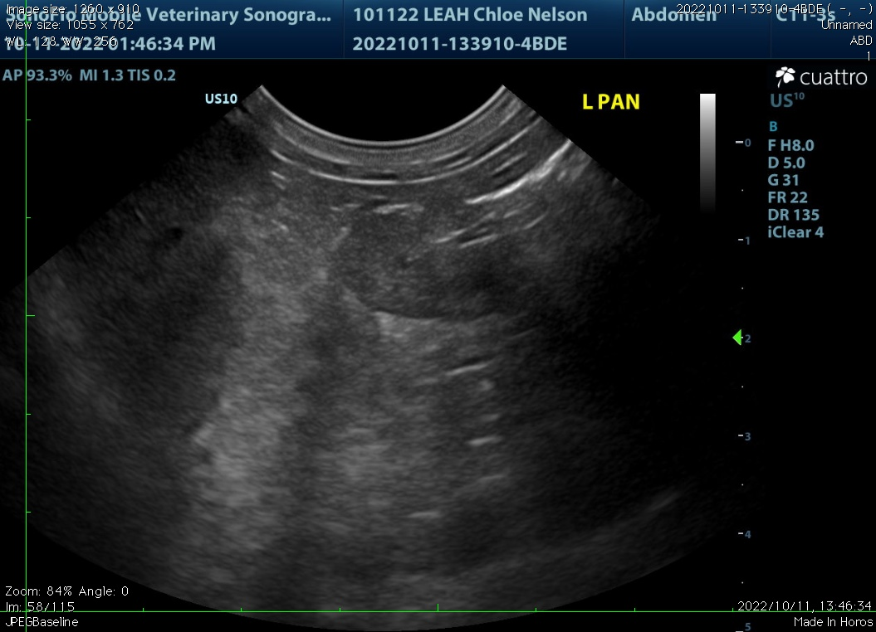

Right adrenal
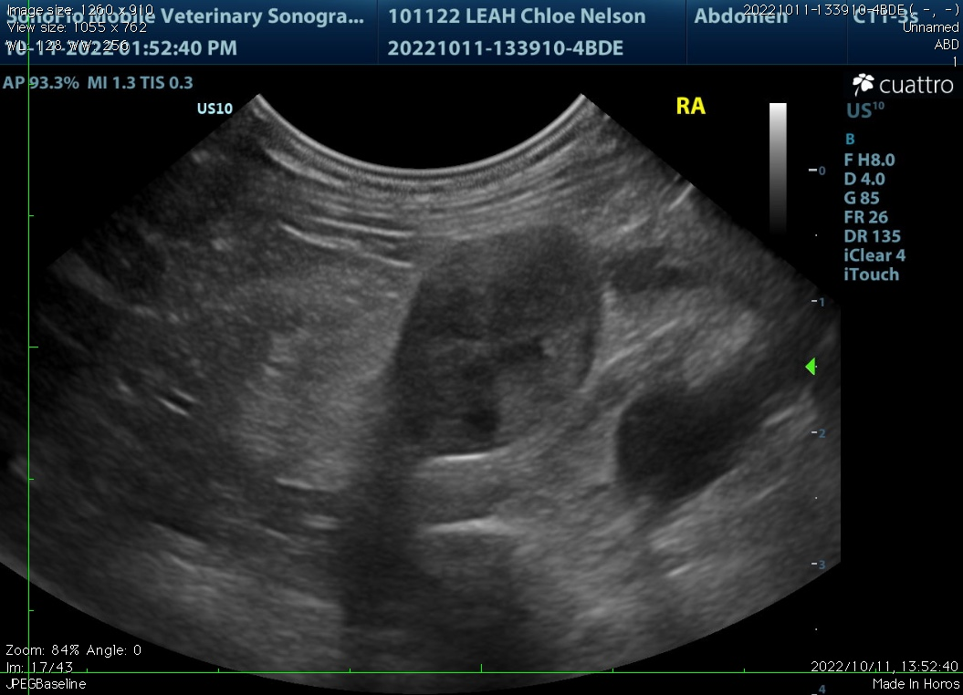
Spleen
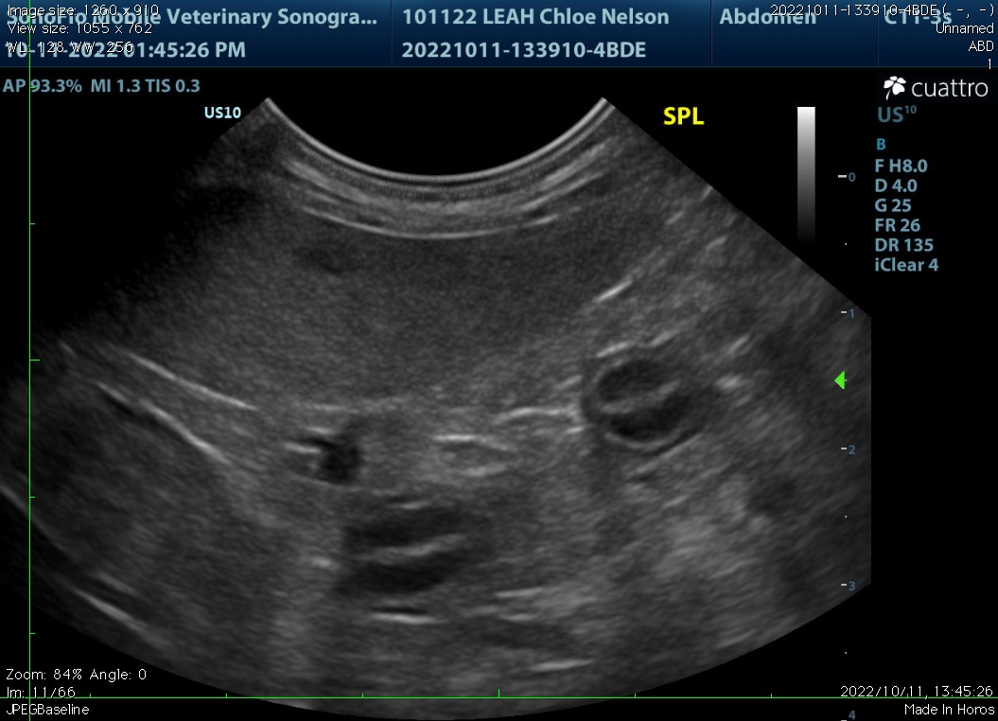

Liver
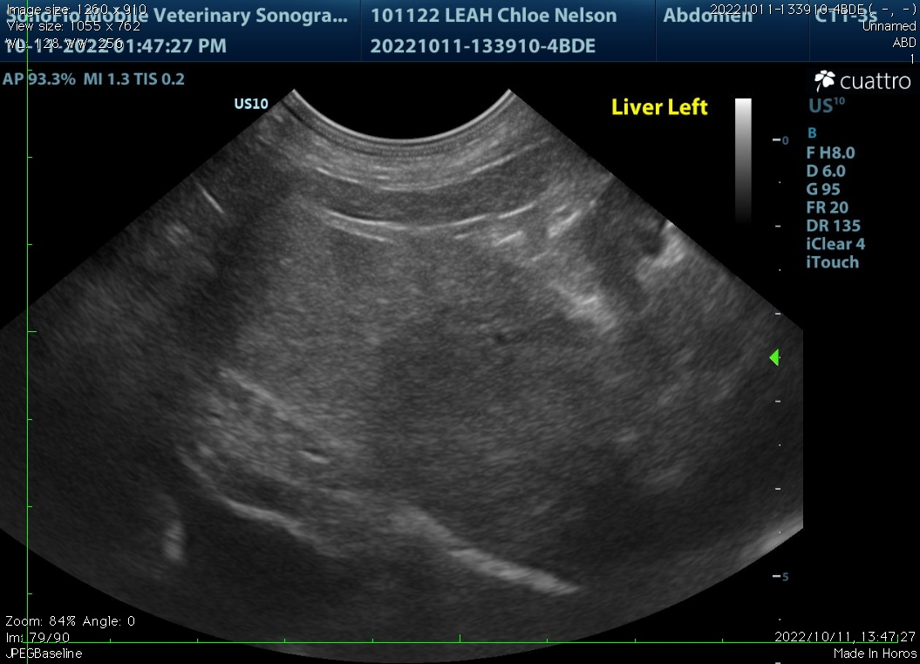
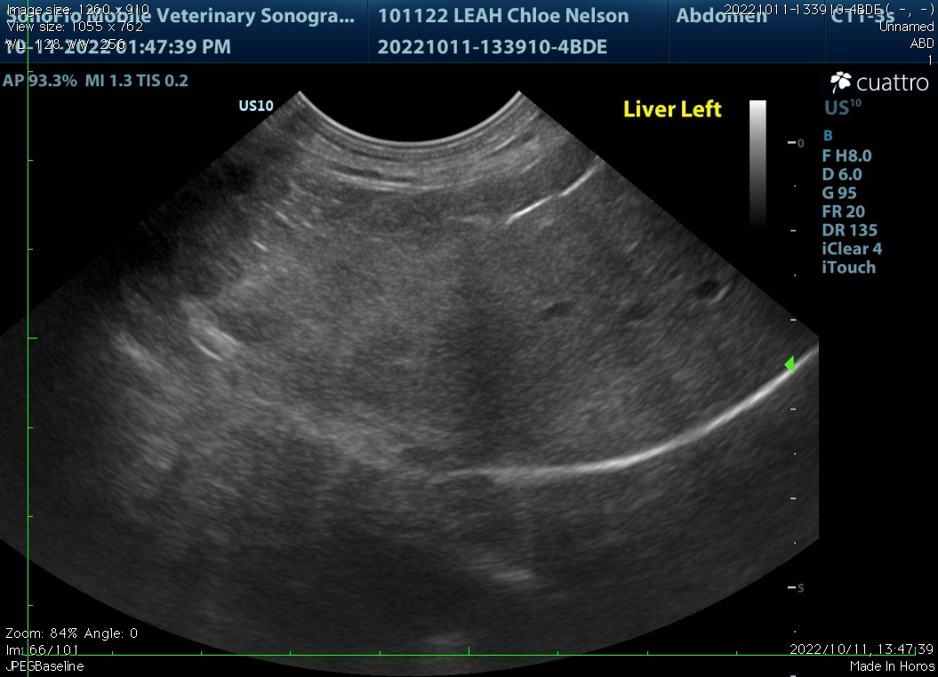

Small intestine
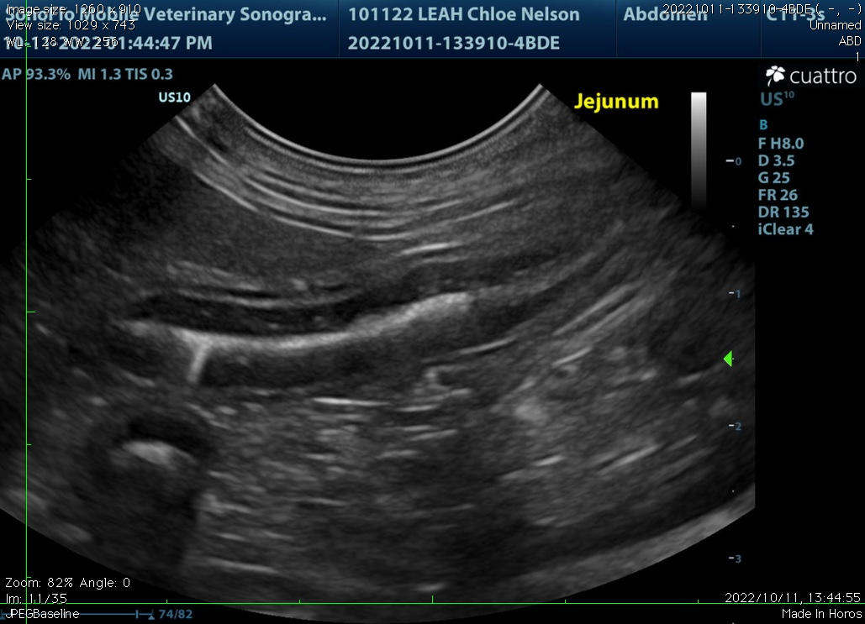

The information and recommendations provided are based on the images presented by the referring veterinarian. No evaluation can be communicated regarding pathology that was not visible in the image/video clips provided.

Thank you for this referral. If the clinical or image interpretation does not parallel your findings or if I can be of any further assistance, please contact me.

Remo Lobetti, BVSc, MMedVet (Med), PhD, Dipl. ECVIM (Internal Medicine)
rlobetti@mweb.co.za

